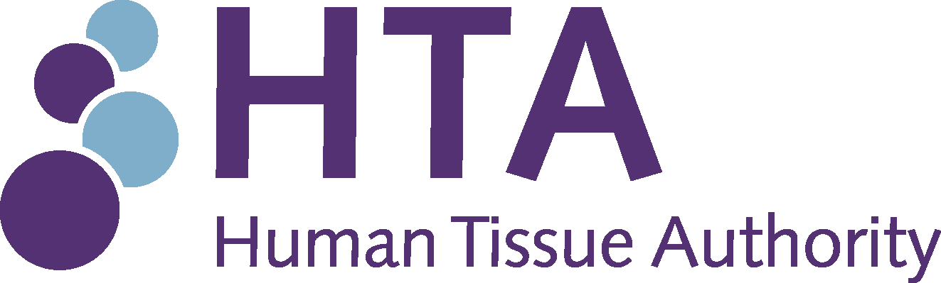
Bequest booklet template
Introduction
- This bequest booklet template provides a suggested format for establishments to provide information about the donation process.
- The booklet template may be adapted, providing it complies with the Human Tissue Act 2004 and follows the Human Tissue Authority’s (HTA’s) Codes of Practice on Consent and Anatomy.
- Parts of the booklet template, which are in italics, should be amended to reflect the specific policies of the establishment.
- The booklet template can be completed to include-
  - Name, address and contact information for licensed establishment
  - HTA licensing number
  - Logo of licensed establishment (the HTA’s logo should not be used)

Authorisation for donation of a body for anatomical examination
And instructions for next of kin and executor

Establishment name Click or tap here to enter text.
Address Click or tap here to enter text.
Contact information Click or tap here to enter text.
HTA licensing number Click or tap here to enter text.

Thank you for expressing your wish to bequeath your body for anatomical examination after death: your generous action is greatly appreciated.
Detailed instructions are enclosed. It is most important that you understand the information contained in this booklet before signing the forms.
If you need any further information please contact us on the above telephone number.
May I express the hope that it will be many years before your wishes have to be considered.

Information and instructions
If you wish to bequeath your body for anatomical examination you should sign the enclosed forms in duplicate, in the presence of a witness. Tear out one copy and return it to the address at the letterhead. Keep the remainder of the document with your will or personal papers. It is advisable to inform your relatives, executor and doctor of your intention. Your executor or next of kin should telephone the medical school as soon as possible after the death occurs. If the bequest is accepted (and it may not be possible to do so) the undertaker employed by the medical school will be instructed to make all the arrangements for removal. The death must be registered with the local Registrar from whom a Certificate of Burial or Cremation and a Certificate of Registration of Death, should be obtained.
The medical school is closed on Saturdays, Sundays and Bank Holidays. There is a voice mail system at the office and relatives should leave their name and telephone number as a recorded message so that we can deal with it promptly. The offer of the bequest will be considered immediately the office re-opens.
If the body lies in a hospital he/she should be held under refrigerated conditions in the hospital mortuary until the office re-opens and can deal with the donation. The maximum time for holding is dependent on the refrigeration. If the body is at home or at a nursing home it should be removed to a Chapel of Rest by an undertaker, and held under refrigerated conditions if possible. If no refrigeration is available the maximum time for such storage is about three days. If the deceased has to be taken to an undertaker’s premises it is important for the relatives to understand that the transport and the cost of the undertaker must be borne by the next of kin or the donor’s estate. The medical school pays for everything else once the donation has been accepted.
During the major public holidays at Christmas, New Year and Easter the Medical School is closed, and as such is unable to accept bodies. During these times, next of kin are advised to make arrangements for a funeral.
The institution that receives the body will be responsible for its examination and preservation until such time as cremation is required. A service will be conducted and relatives and friends may attend. All cremation expenses will be borne by the Medical School. Next of kin may also take possession of the ashes. In addition, an interdenominational Service of Thanksgiving for relatives and friends of those who have donated their bodies is held annually in May. Your next of kin and executors will be invited to attend.
At the time at which the donation of your body is accepted the next of kin or executors may request that there should be a private burial or cremation. In such circumstances all expenses involved in such arrangements become the responsibility of the next of kin or executors.
No guarantee can be given that a bequest will be accepted.

Among other considerations, the cause of death itself or a post mortem examination could have made the body unsuitable for anatomical examination, the object of which is the study of the normal structure of the body.
If the donation cannot be accepted, responsibility for burial or cremation rests with the executors or next of kin.
There is no upper age limit for bequeathing a body.
Although not absolute, the following is a guide to some reasons for not accepting a bequest:
1. Post mortem examination
2. Transmissible disease: for example, Hepatitis, HIV, Septicaemia.
3. Dementia / Alzheimer’s disease
4. Jaundice: of infective origin.
5. MS (Multiple Sclerosis): depending on the severity of the condition, cases of MS may or may not be suitable. If you wish to donate your brain for research into MS please contact the MS Tissue Bank on 020 8846 7324.
6. Artificial Stoma: for example, tracheostomy, ileostomy, colostomy, gastrostomy.
7. Bedsores or varicose ulcers: the doctor or nurse will be asked about the state of the donor’s skin, and in particular about the presence of bedsores. Small sores may be acceptable, but deep sores are not.
8. Peripheral vascular disease: severe vascular disease of the limbs and severe diabetes with evidence of vascular disease would be unacceptable.
9. Recent operations: where the wound has not healed.
10. Peripheral oedema
11. Amputation: of a major segment of one or more limbs.
12. Arthritic deformity: severe deformity of joints and/or spine.
13. Obesity/size: excessive weight or height.
14. Organs donated for transplantation: however you can donate the corneas of your eyes and still donate your body for anatomical examination. For a donor card please contact the Organ Donor Register on 0845 6060400, or Moorfield’s Eye Bank on 020 7253 1199.
If the body is not suitable for anatomical examination the relatives or executors will be informed as soon as possible so they may make funeral arrangements.
Notes for completing these forms
Please read this section carefully as it explains what you may give consent for.
There is no limit on the length of time a donated body can be used by the receiving institution. However, if you wish to restrict the time that your body is used, you have an opportunity to do so in Option 2 of the consent form.
It may be useful for the receiving institution to prepare images of parts of your body for teaching, training or research purposes. You are assured that if consent is given to prepare images you will not be identifiable in these images.
Please ensure the form is signed and dated in the presence of your witness otherwise it will not provide valid consent for acceptance of your body for Anatomical Examination, Education, Training and Research.

Human Tissue Act 2004
Part A: to be completed by person making donation
Please complete in BLOCK CAPITALS
Title
Surname/ family name
Forename(s)
Address
Postcode
Telephone number
Email address
Date of birth
Religion (if applicable)

I wish to donate my body after my death. I understand that it may be used for anatomical examination, education, training, and research.
Please tick as appropriate
Option 1
If you tick this box, go straight to option 3
☐I do not place any restrictions on the length of time that my body or body parts may be retained
Option 2
Please select either a. or b. then proceed to option 3
☐My body can be retained for a maximum of three years only
☐ a. Parts of my body may be retained for longer than three years; or
☐ b. No parts of my body may be kept for more than three years
Option 3
☐I consent to the use of images of my body or body parts. I understand that they will be used for education, training and research and that I will not be identifiable in these images. *Please see footnote.
Please sign and date
Signature
Date

Part B: to be completed by a witness
Please complete in BLOCK CAPITALS
I confirm that I have witnessed _____________________________ (name of donor)
completing PART A of this form.
Title
Surname/ family name
Forename(s)
Address
Postcode
Relationship to donor
Signature
Date

* Footnote
The taking and displaying of images (including photographs, films and electronic images) is outside the scope of the Human Tissue Act 2004; however, the HTA endorses the good practice principles set out in guidance issued by relevant professional and regulatory bodies. For further information, please refer to the HTA’s Codes of Practice, available at www.hta.gov.uk
Data Protection Declaration
By completing this form, and in line with the Data Protection Act 2018, you agree to your personal details being stored by [issuing institution] and only shared with necessary third parties who act on behalf of [issuing institution] to whom the deceased has been accepted.
For further information about how [issuing institution] stores and processes your personal details, and which third parties it is shared with, see the privacy notice at [insert link to issuing institution privacy notice].
Complete both forms. Return one to the issuing institution and keep the other with your Will or legal papers.
Instructions to next of kin or executors when donor dies
You should read the previous information carefully and then telephone (name of establishment and telephone number). The medical school will contact the Doctor in charge of the deceased and together they will make a decision on whether or not the donation is acceptable.
You will be informed within a short time about the decision.
No guarantee can be given that a bequest will be accepted.
If the donation is accepted
1. Register the death with the Registrar and tell him/her of the wishes of the deceased. He/she will issue you with a green certificate (Certificate of Burial or Cremation) and a death certificate.
2. You will be sent a form (some offices colour code the forms, so you may wish to stipulate it is e.g. a pink or yellow form – some offices use both, one for the LAO and one for the medical school) from this Office. This calls for a final decision on cremation arrangements.
3. Send the form, the green certificate and a copy of the death certificate to the medical school. It is very important that we receive these documents as soon as possible.
4. If the deceased has had to be maintained at an Undertakers prior to acceptance the cost will be borne by the estate of the deceased. The medical school only pays from the time its undertakers take charge of the deceased.
If a donation is not accepted
Proceed with normal arrangements for burial or cremation. It is regretted that the medical school cannot make any financial contribution to these private arrangements.

